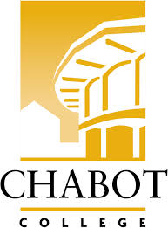**Career Education (CE Committee)**

Chabot College – Zoom

Monday, March 24, 2025

12:00-1:00

**AGENDA**

1. Welcome & Land acknowledgement – Terra
2. Review and approve minutes of last meeting - Kristina
3. Announcements
   1. Professionals in the Legal Field Workshop – Robin
   2. CE one-page overview and other marketing tools
   3. CE Events (on campus)
      1. Paving a Path for the Future, Mental and Behavioral Health Workforce, Bay Area Regional Convening - 3/25
      2. SOAR Day – 4/19
      3. ECD Job Fair – 4/29
      4. ROP Digital Media Day – 5/2
      5. Ambulance Meet & Greet Day – 5/23
4. Career Education Open House reflection and feedback
5. CE Website – Robin
   1. Website discussion recap (5 min)
   2. Breakout groups/discussion (15 min)
   3. Breakout group reports (5 min)
6. Good of the Order - Kristina
7. Next Meeting 4/14/2025
8. Adjournment

**Mission Statement**

*Chabot College is a dynamic, student-centered community college that serves the educational, career, job skill, and personal development needs of our community. We provide culturally responsive, revitalizing, and sustaining learning and support services driven by a goal of equity. Building upon students’ strengths and voices, we empower students to achieve their goals and lead us towards an equitable and sustainable world.*